Henkel
Functional Design Specification
SampleManager PhaseB

Document Reference | xxxx-FDS-SAMPLEMANAGER-B001
Version | 1.2
Last updated by | Zhenjuan.Zhang
Template Version | 1.0-0
Date
Status | Draft

Document Signoff
Name | Position | Company | Signature | Date

Table of Contents
Contents
1 Table of Contents 3
2 Introduction 5
2.1 This Document 5
2.1.1 Document overview 5
2.1.2 Disclaimer 5
2.1.3 Purpose 5
2.1.4 Scope 5
2.2 Synopsis 5
2.3 Definitions 5
2.4 References 6
3 Project Brief 7
3.1 Project Overview 7
3.1.1 Project detail 7
3.2 Functional Requirements 7
3.2.1 Sample Management 7

Version Management
Version | Description | Name | Date
1.0 | Created | Zhenjuan.Zhang | 2025/05/20
1.1 | Add chapter 3.2.1.4 and 3.2.2 | Zhenjuan.Zhang | 2025/06/16
1.2 | Add chapter 3.2.1.5 | Zhenjuan.Zhang | 2025/07/04

Introduction

This Document

Document overview
This document describes the system functionality of Phase B pilot stage covered in the Henkel QCLad System RTM User Requirements Analysis Report.

Disclaimer
The screenshots used below are screenshots generated during the system standard functions or system configuration, as well as customer sample screenshots, the final design may be different from the screenshots in the document, and the data on the screenshots is not the real data of the system, only for reference.

Purpose
This document is used to provide a detailed description of the functionality of the SampleManager system, identifying a description of the system functionality that meets the user's business needs as specified in the phase B pilot stage of User Requirements Analysis Report. The functionality of phase A, which is already deployed in the system, will not be described further

Scope
- Document the functional specifications of the laboratory management system based on the requirements described in the User Requirements Analysis Report.
- Determine the implementation of functionality in the system based on the needs described in the user needs analysis report

Synopsis
The core application functionality of the QCLad system is the laboratory sample process management functionality, including sample management, SAP interface, task scheduling, master data, reporting, architecture and security.;

Definitions
The following abbreviations and definitions are assumed throughout this document.
Term/  Abbreviation | Meaning | Description
FS | Function Specification | This Document
RMB | Right Mouse Button | Using RMB various Sample Manager options can be displayed
QCLAD | SampleManager | Software Name

References
The following references are made in this document.
Ref. No. | Reference | Description

Project Brief

Project Overview

Project detail
Implementation of SampleManager QCLad will streamline Sample Management, Reports, Dashboards, Instrument and Equipment management, Instrument interfacing and External application integration together with the associated data acquisition across Henkel’s labs.

Functional Requirements

Sample Management

Lab Testing Process Workflow

Business Scenarios
Generally, samples and tests will flow the process of workflow which is deployed during project stage phase A. In this document it will be referred to as the lab testing process and will be used in the lab as a base process for other subsequent workflows.

RTM Mapping

URS Ref. | Requirement | Type
4.1.5.1.1 | System shall be able to manage Standard RM test for Incoming workflow. （Standard RM） | Configuration
4.1.5.1.2 | System shall be able to manage Standard in process testing for semi finished and finished goods workflow. （without MES) | Configuration
4.1.5.1.3 | System shall be able to manage Standard finished goods outgoing test workflow. | Configuration
4.1.5.1.10 | System shall be able to manage Test for SCMS/NCMR /CCMS investigation workflow. | Configuration

Function Design
The lab testing process workflow defines the lifecycle of a sample from received status to authorization. See the flow chart below.
Samples and tests will be run according to this workflow if not otherwise specified.
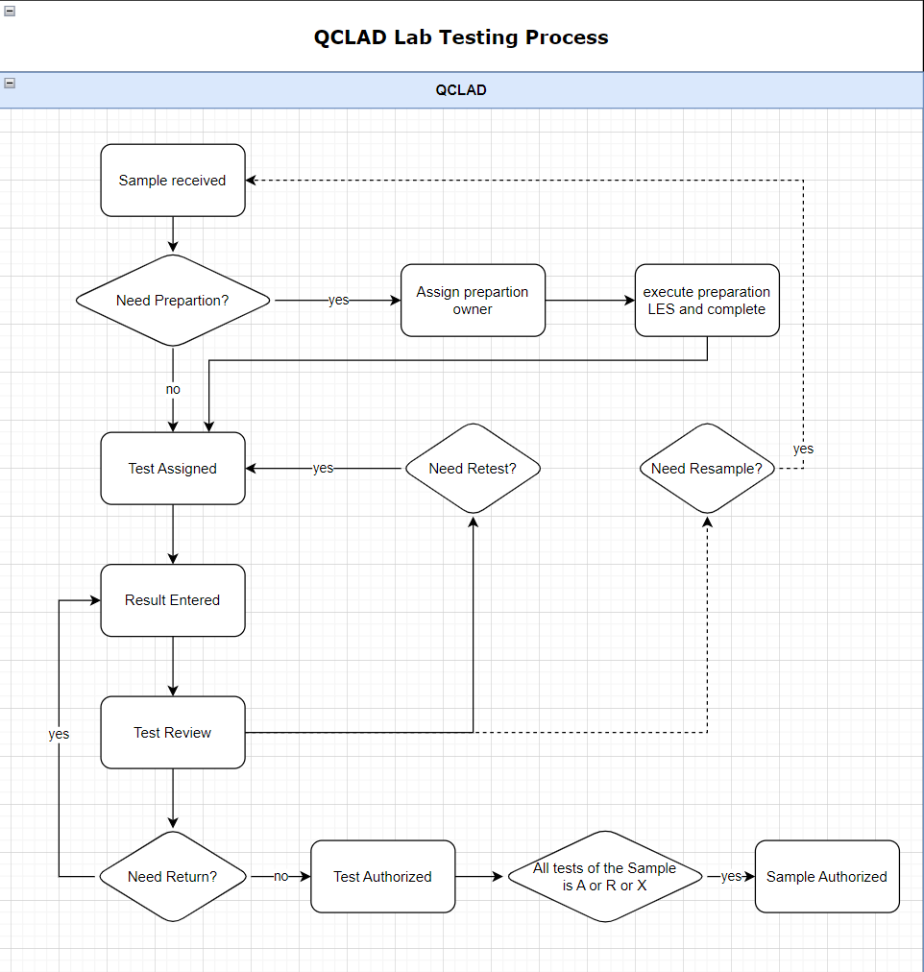

Truck Workflow

Business Scenarios
There are TRUCK samples that need to be created manually first, and then the sap inspection batch will be pushed. QCLAD needs to be able to return the results correctly.

RTM Mapping
URS Ref. | Requirement | Type
4.1.1.1.1 | System shall be able to login samples using configurable templates | Configuration
4.1.1.1.3 | System shall be able to create samples manually for standard testing. | Configuration

Function Design

Design Overviews
Users can create Tank samples and tests manually. QCLAD shall retrieve the results to SAP after inspection lot is received. (Based on RTM as above).
In the Sample management cabinet, samples and tests will be displayed in subfolders categorized by sample type. Truck sample will be grouped in sub folder IQC-TRUCK.

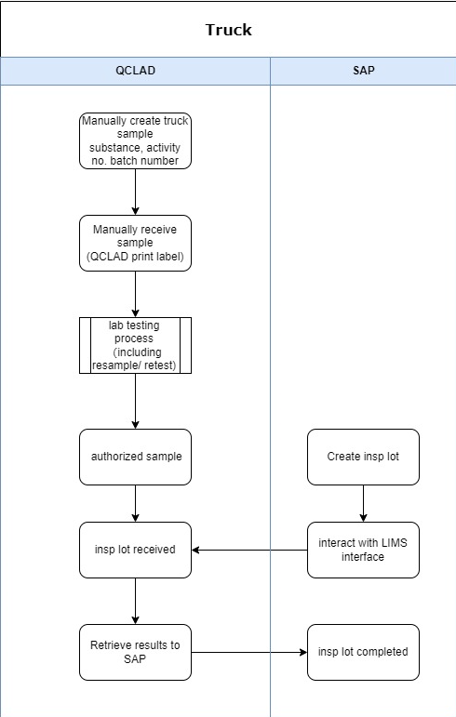

Process Design
Sample Login:
Truck Samples will be login by manually running sample login workflow Truck Sample by navigating to: Public folders-Sample Management-Create Sample.
The user needs to select the MLP and enter the batch number. QCLAD system will automatically fetch the IDH and activity number from the master data.
For truck material, creates the sample id by adding the entries.

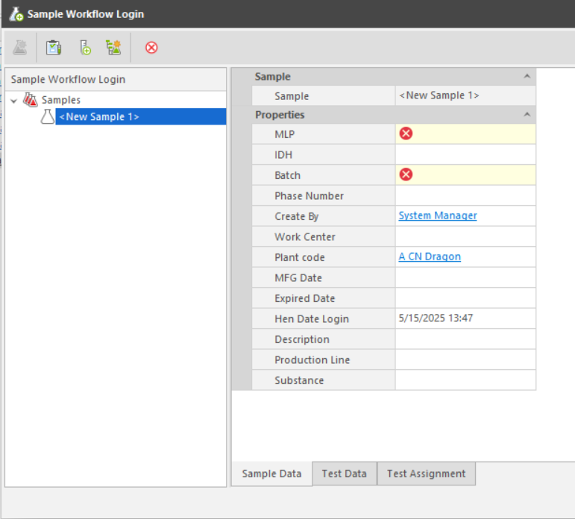
Properties in entity template clarification in LIMS:
No. | Properties | Type | Prompt Type | Description
1 | MLP | Identity | Mandatory | Links to MLP table
2 | Batch | Text | Mandatory | Batch id
3 | Plant code | Text | Optional | Links to Plant table
4 | Activity No | Numeric | Optional | Fetch from MLP
5 | Work Center | Text | Optional | Links to Work centre table
6 | Date Login | Date | Optional | Current date, modifiable.
7 | Create By | Operator | Optional | Current operator
8 | Description | Text | Optional | Descriptiom
9 | Substance | Identity | Optional | Fetch from MLP
10 | MFG Date | Date | Optional | Manufacture date
11 | Expired Date | Date | Optional | Expiration date
14 | Production Line | Identity | Optional | Fetch from MLP
Sample Receiving:
The user needs to find the specified sample from the New Sample Pending Receiving folder and right-click Receive Samples button to open the Sample Receiving window. After the sample is received, the sample label is automatically printed to the label printer in the corresponding work centre.
Sample Authorize:
When all tests for a sample are in the authorized or rejected status, the sample will automatically become authorized.
Authorized JIT samples will be listed in the Sample management-Authorized samples folder. System will highlight the JIT samples which has not received inspection lots from SAP by highlighting the background color in the Authorized samples folder.

Truck Samples are not automatically marked as waiting to be sent results to SAP when the sample is authorized, but need to wait for a response from the sap interface.

SAP interactive
Truck sample is created manually in QCLAD system.
When inspection lot created in SAP is pushed to QCLAD, interface would find the sample already existed in system and save the inspection lot number in the field ‘hen_inspection_lot’ and mark the field ‘hen_to_be_sent’ to true.

JIT Workflow

Business Scenarios
There are JIT samples that need to be created manually first. When all tests are all completed and reviewed, QCLAD will send the message which including sample decision information(A/R) to the MES. Then SAP will push the inspection lot and QCLAD needs to be able to return the results correctly.

RTM Mapping
URS Ref. | Requirement | Type
4.1.1.1.1 | System shall be able to login samples using configurable templates | Configuration
4.1.1.1.3 | System shall be able to create samples manually for standard testing. | Configuration

Function Design

Design Overviews
Users can create JIT samples and tests manually. QCLAD shall send the message to MES when sample is authorized and retrieve the results to SAP after inspection lot is received. (Based on RTM as above).
In the Sample management cabinet, samples and tests will be displayed in subfolders categorized by sample type. Truck sample will be grouped in sub folder IQC-JIT.

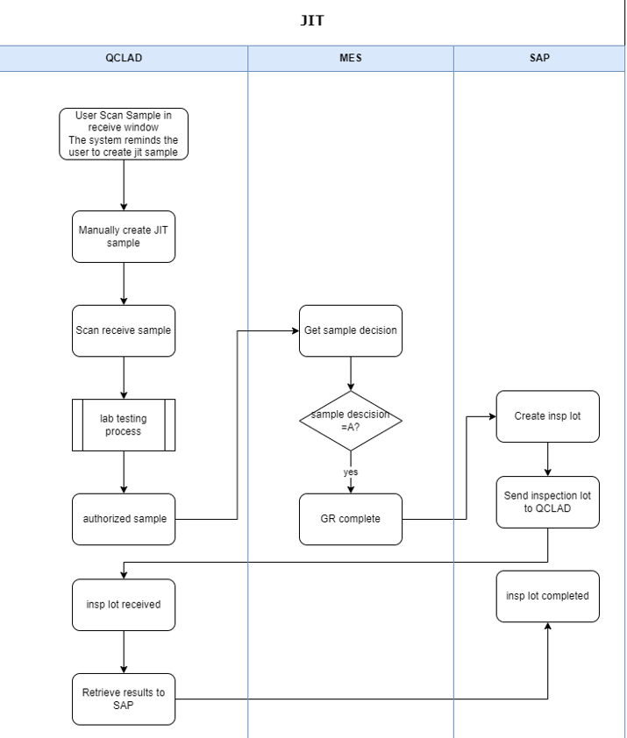

Process Design
Sample Login:
JIT Samples will be login by manually running sample login workflow JIT Sample by navigating to: Public folders-Sample Management-Create Sample
System shall remind user to create JIT sample when scanning receive the sample which has not yet been created in QCLAD
The user needs to select the MLP and enter the batch number. QCLAD system will automatically fetch the IDH and activity number from the master data.


Properties in entity template clarification in LIMS:
No. | Properties | Type | Prompt Type | Description
1 | MLP | Identity | Mandatory | Links to MLP table
2 | Batch | Text | Mandatory | Batch id
3 | Plant code | Text | Optional | Links to Plant table
4 | Activity No | Numeric | Mandatory | Activity number
5 | Work Center | Text | Optional | Links to Work centre table
6 | Date Login | Date | Optional | Current date, modifiable.
7 | Create By | Operator | Optional | Current operator
8 | Description | Text | Optional | Descriptiom
9 | Substance | Identity | Optional | Fetch from MLP
10 | MFG Date | Date | Optional | Manufacture date
11 | Expired Date | Date | Optional | Expiration date
14 | Production Line | Identity | Optional | Fetch from MLP
Sample Receiving:
Users can receive sample by scanning the MES label in sample receive window or manually finding the specified sample from the New Sample Pending Receiving folder.
After the sample is received successfully, the sample label is automatically printed to the label printer in the corresponding work centre.
The MES label should have a QR code that contains the information in the same format as phase A.
When a user scans to receive a JIT sample but the sample has not yet been created in QCLAD, system will remind the user in the scan window that the sample is a JIT sample.
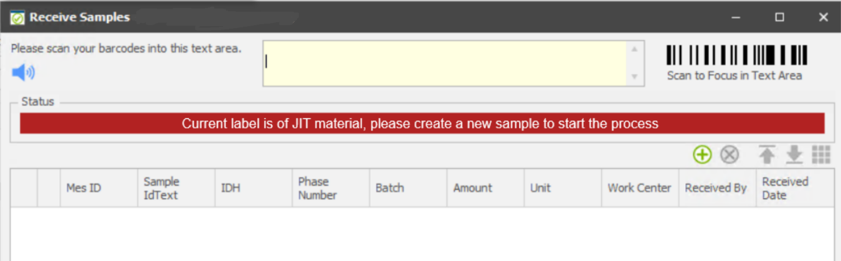
Sample Authorize:
When all tests for a sample are in the authorized or rejected status, the sample will automatically become authorized.
Authorized JIT samples will be listed in the Sample management-Authorized samples folder. System will highlight the JIT samples which has not received inspection lots from SAP by highlighting the background color in the Authorized samples folder.
JIT Samples are not automatically marked as waiting to be sent results to SAP when the sample is authorized but need to wait for a response from the sap interface.

SAP interactive
JIT sample is created manually in QCLAD system.
When inspection lot created in SAP is pushed to QCLAD, interface would find the sample already existed in system and mark it as waiting to be sent results.

MES interactive
When the sample is authorized, QCLAD determines the sample decision based on the on spec field on the sample table and sends a string to the MES interface.

Retain Samples Workflow

Business Scenarios
The laboratory will retain authorized samples for a certain period of time in the sample retention room. Samples may be taken out for testing during the retention period. The samples will be scrapped after the expiry date.

RTM Mapping
URS Ref. | Requirement | Type
4.1.6.1.2 | System shall be able to support QC retain sample, consumables and spare parts can select location. | Configuration
4.6.1.16.1 | System shall display retain sample in dashboard by storage location, retain status , number of expired retains, disposed retains by date. | Customization
4.8.5.3.1 | System shall allow user to record and retrieve the storage location of samples stored in QC by providing material, batch information. | Configuration

Function Design

Design Overviews
Users can trigger sample retain by click on retain sample button or right click on samples, scanning sample labels in the barcode scanning window.
When retaining a sample, User can assign it to a lab basket. And the baskets can be assigned to bins.
Users can scrap the retain samples by scanning the bin or basket label to scrap by bin or scanning sample label to scrap by sample.
Retain location hierarchy:

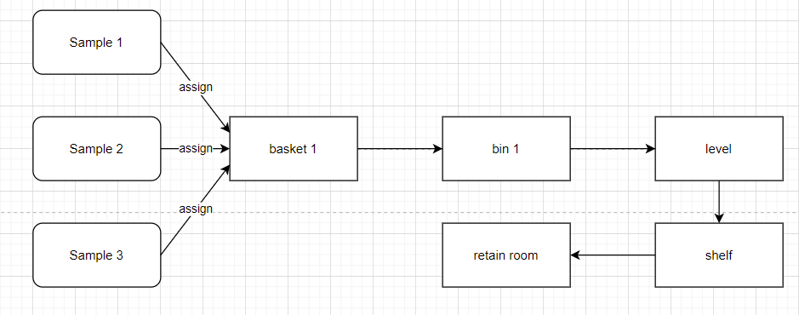
Retain sample workflow:

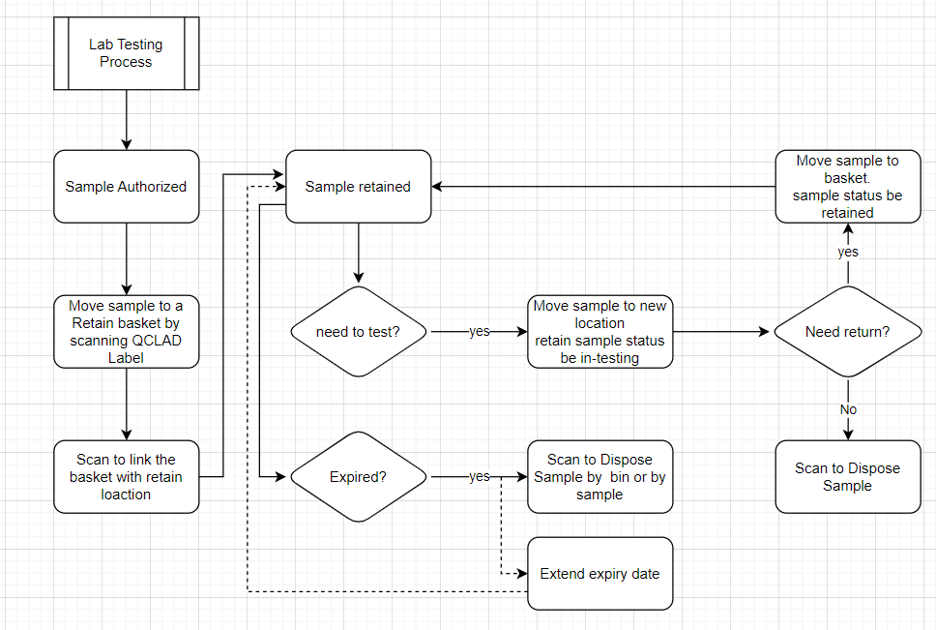

Process Design
Sample Retaining:

User can trigger retain scanning process by clicking retain sample button.
User shall scan the QCLAD label on the sample and select the location by scanning the label on basket to retain sample in the basket. If there is no basket concept at plant level, user can scan the bin QR code.
If the bin is set up with a work center limit, then only samples belonging to that work center are allowed to be placed in it.
System shall record the retain date, retain amount(optional) and operator.
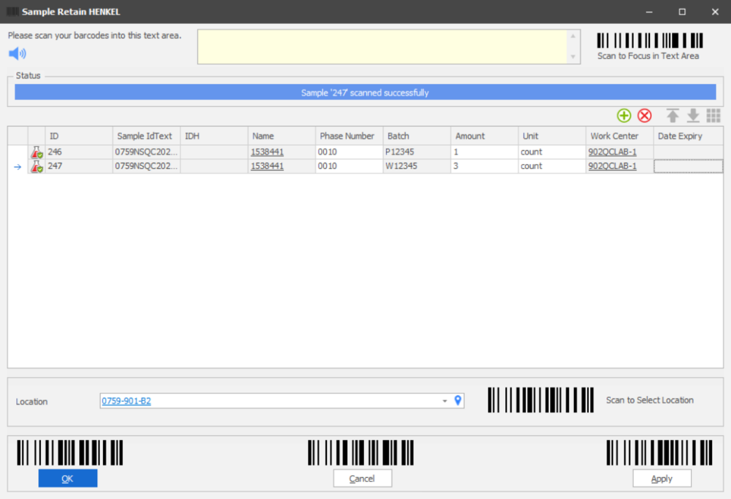
Click OK or Apply to retain the sample in the basket.
Basket Move Location
Each Basket kept in the bin has its own parent location, the bin.
Baskets listed can be found in retain baskets folder where bin information is displayed.
If user wants to assign the basket to a new bin, user can click the Move Basket to new Bin button and scan the basket label. Then scan the bin label in location field to move.
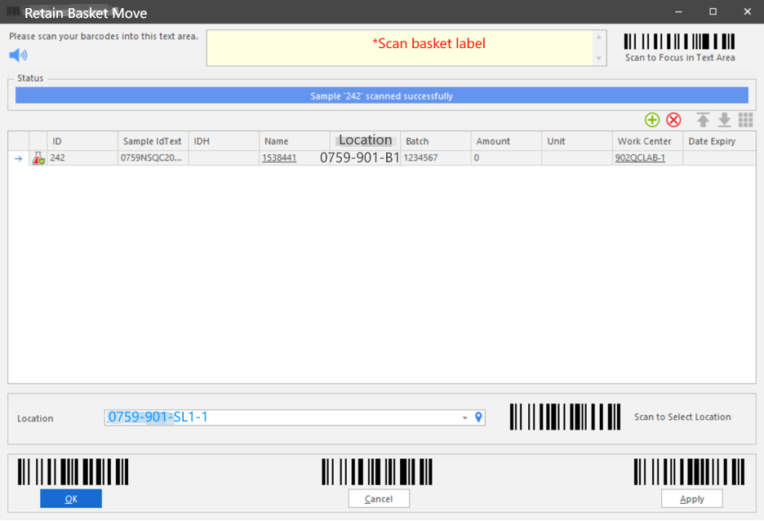
Retain Query
Retain samples will be listed by location and basket in retain samples by location folder.
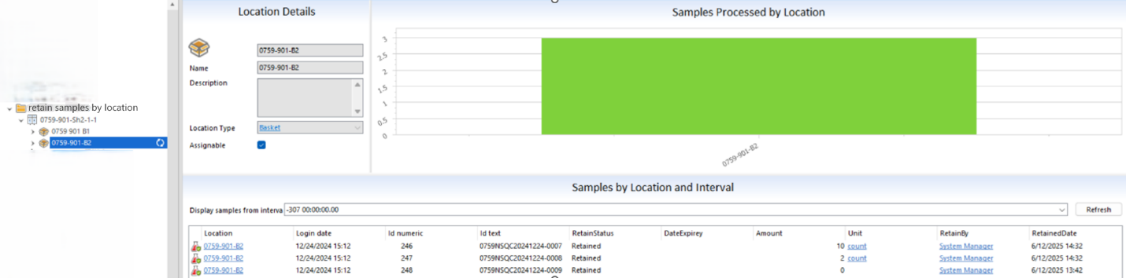
The Expired retain samples will be displayed in the expired retains folder
The Bins will display the oldest expire date from all its stored samples in the bin list folder.
The Bins whose retain samples stored are all expired will be displayed in to-be scrapped folder.
Retain Sample Take-out
User can take out the whole retain sample for other use by clicking button take out retain. User shall assign a new location to take out the sample. Once the retain sample is taken out, its retain status would be take out.
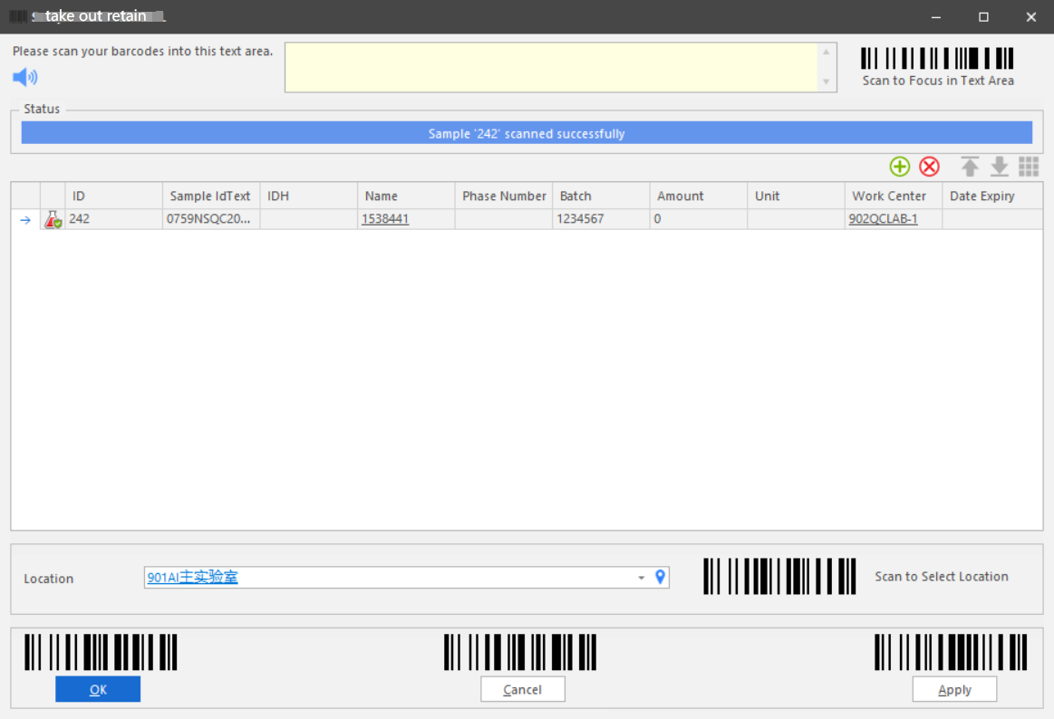
After usage of retain sample, user can return the sample to retained by return retain sample button or scrap the sample by scrap retain button.
Retain Sample Return
After a retain sample is taken out, if user wants to return it to retain storage, User shall click return retain sample button. Scan the sample label and basket label and record return amount.
User can modify the expiry date in the sample return scanning window. The expiry date is a mandatory field when returning retain samples.Once the retain sample is returned, its retain status would be retained.
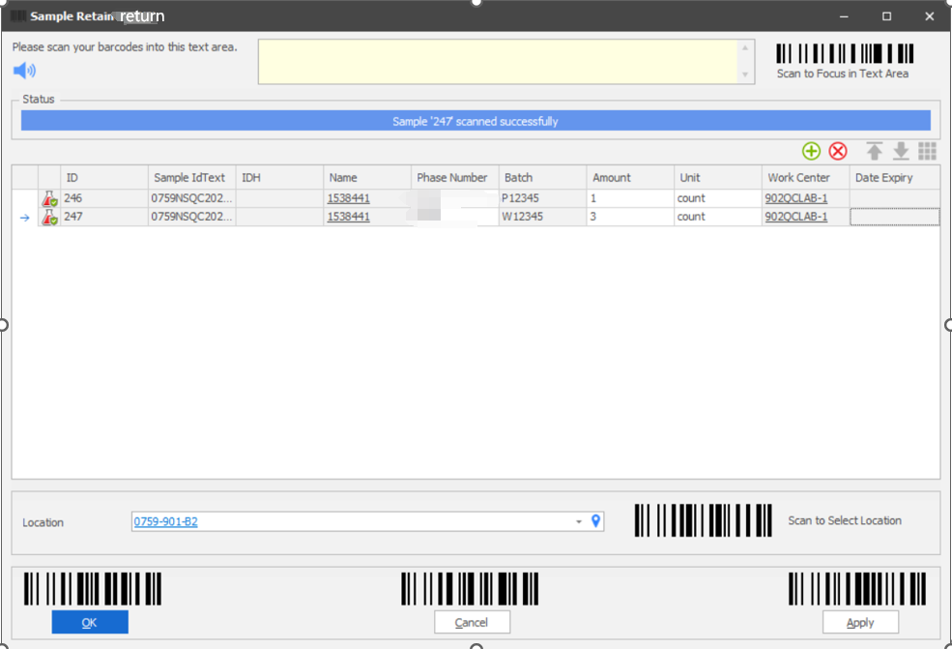
Retain Scrap
User can scrap the retain sample by samples by sample or by bin.
If the bin method is used, all samples in the bin will be scraped together by scanning basket label.
System shall record the scrap amount, scarp date and operator. And the retain sample status would be ‘scrapped’. The scrapped samples will be displayed in scraped retain folder.
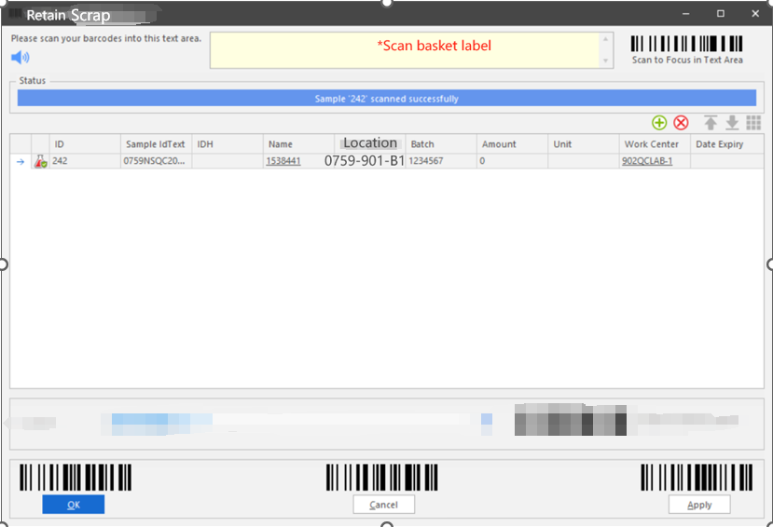
Retain Expiry Date Extension
User can extend the retain expiry date by 2 ways:
- When a retain sample is returned, the expiration date can be modified in the return scanning window. The expiration date field is mandatory when returning the retain sample.
- User can use modify expiry date button on retain samples or scan the sample label to modify expiry date.

      - Consumables Workflow
        - Business Scenarios
When stock is put into storage, some stock types need to be tested. Only after the test sample is authorized can consumable be released for use.
User will consume certain stock batch when performing testing.
        - RTM Mapping
URS Ref. | Requirement | Type
4.1.5.1.4 | System shall be able to manage Consumables incoming test workflow. | Customization
4.1.6.1.2 | System shall be able to support QC retain sample, consumables and spare parts can select location. | Configuration

        - Function Design
          - Design Overviews
Consumables are maintained in the system in the Stock module. When a stock is set up to require an inspection plan (MLP), QCLAD will automatically generate a test sample when that stock batch is created.
Until this sample is authorized, the stock batch will be in an unavailable status.
Once the sample is approved, the system will automatically release the inventory lot based on whether the sample passes or fails its specification, or user can manually release it.
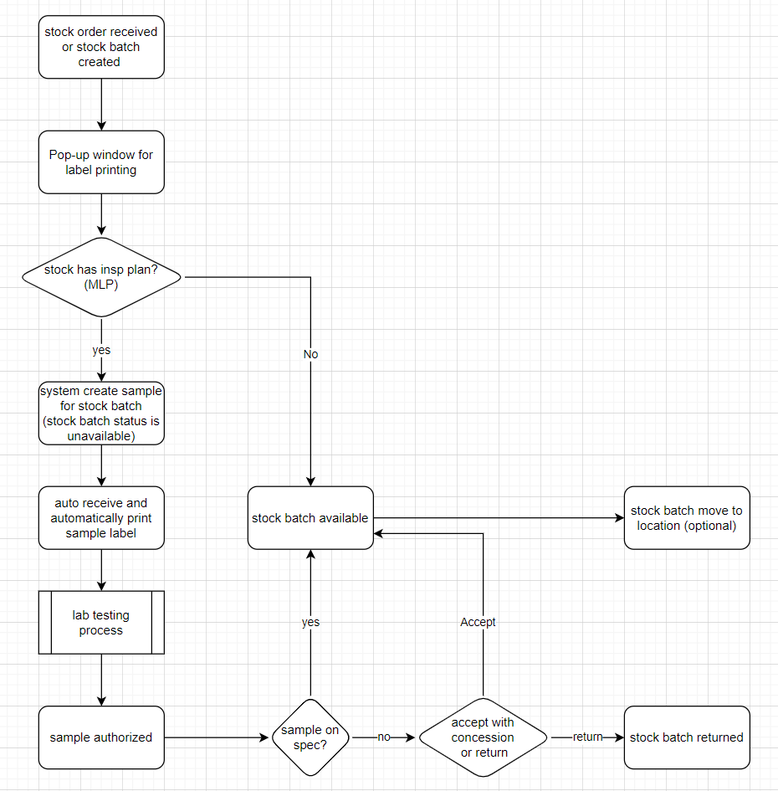
          - Process Design
Master Data
MLP information should be maintained in the STOCK master data, similar to the master data for other routine samples, where test schedules and corresponding specification information are associated with this MLP. The system will use this MLP to create test samples.
The label template that defines the label design that can be created for stock batches associated with the stock.
The Auto Consumption checkbox is used to determine if this stock can be used to automatic stock consumption during testing.
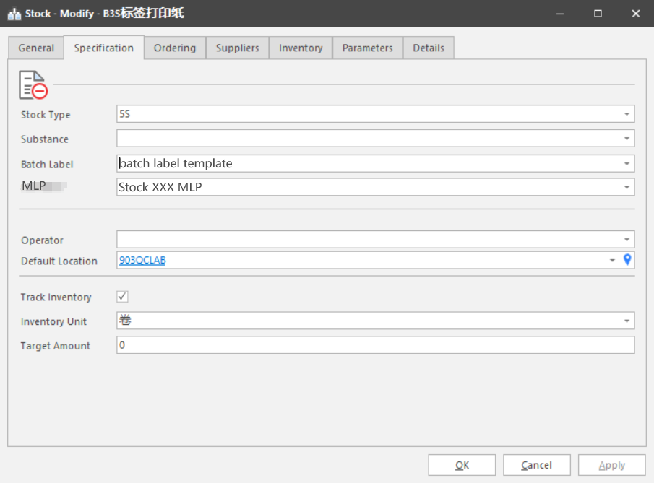

Stock Batch Creation:
When creating stock batches, Expiry date and batch number is mandatory if its stock is checked ‘Auto Consumption’ in master data.
If a stock batch is created by stock order, expiry date and batch number are mandatory when receiving order. Group information shall be fetched from stock master data.The group shall be mandatory and allow user to modify it.
When a stock batch is created in QCLAD system, by stock order receiving or directly adding stock batch, the system will pop up a window asking for printing label quantity.
By default, the label quantity is 1 and the printer is the work center printer. Label template is the label template defined in stock master data. User can modify the number of printing labels or label template or another QCLAD printer.
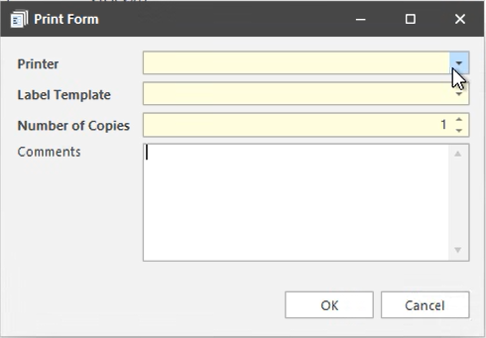

Sample Login:
When a stock batch is created in QCLAD system, by stock order receiving or directly adding stock batch, the system will check its stock master data to determine if there is MLP selected for that stock.
If there is, then a sample will be created automatically according to the MLP, its sample type would be IQC-CON and its work center will be pulled from substance master data. The stock batch will be displayed in stock batches unavailable folder in Stock Management cabinet;
If not, then the stock batch will be directly released to available status.

Sample Process:
The consumable samples will be listed in samples pending receiving folder. When user receviing the sampe, A sample label will be automatically printed by the work center printer.
Users can complete testing of the sample according to the Lab Testing Process Workflow in Sample Management cabinet folders.

Stock Batch Release:
When all tests of the sample are authorized, the sample get authorized:
If all tests under that sample meet the specification criteria, the system will automatically release the stock batch. Its status will become available;
If any of the tests under that sample do not meet the criteria, the system will not automatically release the stock batch. Its status will become Await Decision. User can manually click right mouse button to decide whether to return or release.
All returned stock batches are displayed in the Returned Stock Batches folder.
User can move the stock batch to its storage location using Move Batch button.

Automatic Consume Stock Batches to a Test:
To enable automatic stock consumption during testing, the following conditions must be met:
1. In Analysis master data, stock, consumption quantities and unit are required for the corresponding IDH.
2. There are available stock batches corresponding to analysis.
The automatic consumption deduction logic is shown in the flowchart below.
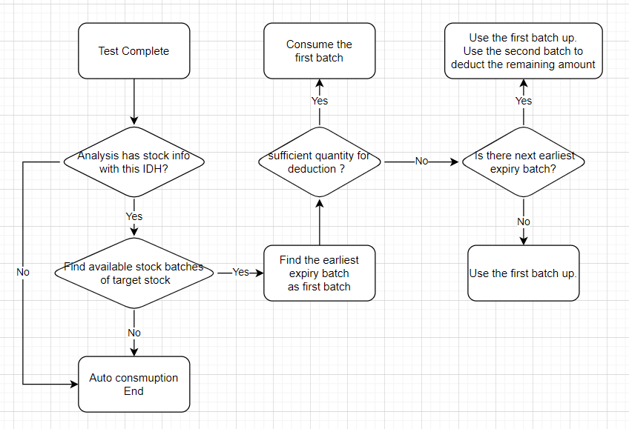
If the actual deduction amount is less than the target amount during the automatic deduction process, the system will pop up a window to remind the user of the relevant information.

Modifying Stock Batch Consumed to a Test
Users can click the newly added button on the Result Entry Window to open the Stock consumption window.
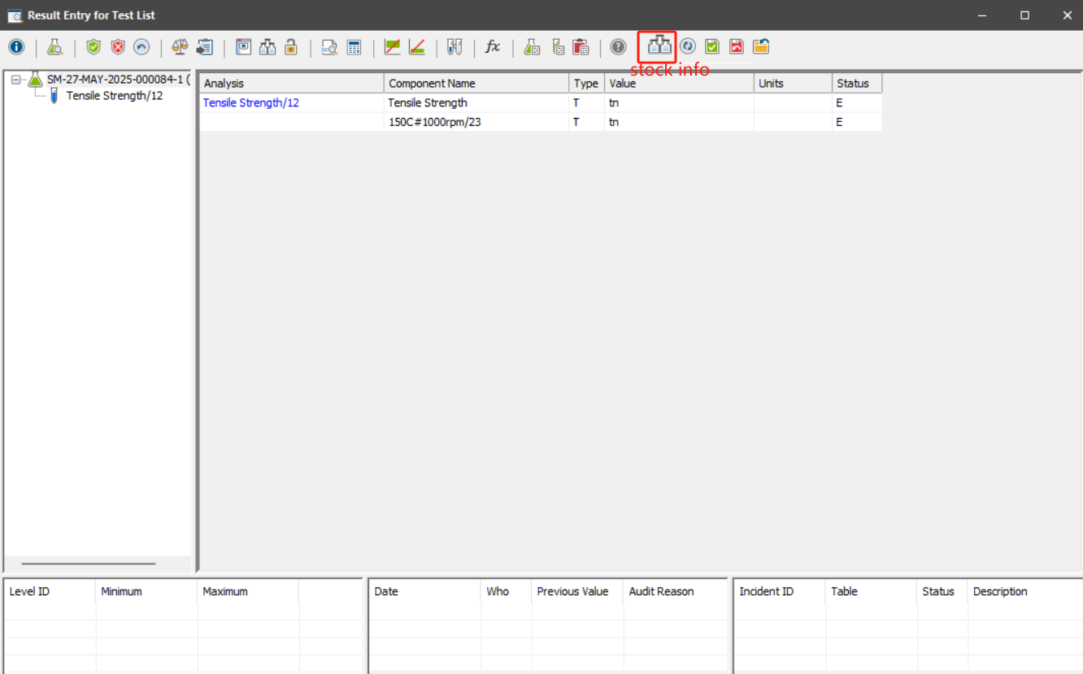
In the stock consumption window, system will list the stock batch and the amount consumed.
User can modify the stock batch or the consumed amount in the stock consumption window only when test has not been authorized.

Sample Test Assignment Procedure

Business Scenarios
For the task assignment function, it is desired to add the function of automatically assigning tasks to operators based on the phaseA manual assignment function. The system needs to automatically assign tasks based on shift scheduling information and operator qualifications, and it also needs to take into account the handling of shift handover situations.

RTM Mapping

URS Ref. | Requirement | Type
4.1.2.1.4 | System shall be able to assign test based on the versatility matrix from OSDP system once integrated. | Customisation
4.2.1.1.12 | System shall be able to assign test based on the versatility matrix from OSDP system once integrated. | Customisation
4.2.1.1.13 | System shall be able to assign test based on the sample status (Waiting to start). | Customisation
4.2.1.1.14 | System shall be able to auto assign for the current date based on the schedule configured. | Customisation
4.2.1.1.15 | System shall be able to monitor samples on a certain interval basis and assign it. | Customisation
4.2.1.1.17 | System shall be able to assign samples based on SAP test skip lot rules. | Customisation
4.2.1.1.18 | System shall be able to assign samples based on other pending QC works. | Customisation
4.2.1.2.1 | System shall be able to modify schedule. | Customisation
4.2.1.3.1 | System shall be able to allow key user modify task based on urgency test. | Configuration
4.2.1.4.2 | System shall be follow FIFO rules based on sample receiving date when assigning tasks. | Customisation
4.2.1.5.1 | System shall assign task based on priority rules once sample arrives. | Customisation
4.2.1.6.1 | System shall allow to create tasks based on calendar schedule. | Customisation
4.2.1.9.1 | System shall check skill when assigning tasks to operator. | Customisation

Function Design
When a sample is received and the status changes from unavailable to available, it is considered that the tests under the sample can be assigned automatically and the system will assign the test according to the following rules.

Sample Assignment upon Receipt
When a sample is received, automatically assign its tests based on the following logic:
- Find available personnel who are:
  - On duty that day
  - Match the Plant, WorkCenter (from personnel's WorkCenters), and Production Line (from personnel's Production Lines)
- Check if the sample's tests require training courses:
  - If yes: Assign tests individually to personnel qualified for each test's training course.
    - Exception: If personnel meet condition (a) and are qualified for all tests in the sample, assign the entire sample to them.
- If no tests require training courses: Assign all tests in the sample to one person.
- When multiple tests under the same TestMethod in the same sample have the same eligible staff, these multiple tests will be assigned to the same person.
- Multiple eligible personnel:
  - Assign to the person with the lightest workload (fewest unfinished samples with status "V").
  - If equal, assign to the first person in the list.
- No eligible personnel found: Do not assign the test/sample.
- Use the ‘Starter’ field in the test table to automatically determine whether the test is assigned based on whether it is empty.

Scheduled Background Assignment
Set up a scheduled task to assign unassigned tests with this logic:
- Only assign unassigned tests.
- Priority order:
  - IPQC-type tests
  - Truck-type tests
  - Other types
- Assign oldest received tests first.
- Find personnel who are:
  - On duty that day
  - Match the Plant, WorkCenter (from personnel's WorkCenters), and Production Line (from personnel's Production Lines).
- Training course check (same logic as 1.b).
- If no tests require training: Assign entire sample to one person (same as 1.c).
- When multiple tests under the same TestMethod in the same sample have the same eligible staff, these multiple tests will be assigned to the same person.
- Multiple eligible personnel: Same as 1.d.
- No eligible personnel: Do not assign.
- Frequency: configured by the user. it is recommended to do this once a day.

Task Release during Shift Handover
When personnel end their shift:
- Release all their unfinished tasks (status "V", available).
Behavior：Users can select multiple tests or samples assigned to themselves, right-click ‘Task Release’, and release the selected tests or samples assigned to themselves, i.e., set the ‘Starter’ field in the test table to empty.
Note: In case the user did not release or forgot to release the task, the system will not process it in any way.
- These tasks become available for reassignment via the scheduled background assignment (Section 2).
- Add"My Tasks" Folder:
Purpose: Streamline test management by allowing users to quickly locate and release their unfinished tests during shift changes.
Access: Tests are filtered by the logged-in user and can be configured by an administrator.

